Linux 平台下C/C++的自动编译

## 环境搭建

需要安装的各种工具包

|  |  |  |
| --- | --- | --- |
| gcc-4.4.7-16.el6.x86_64 |  |  |
| gcc-c++-4.4.7-16.el6.x86_64 |  |  |
| autoconf-2.63-5.1.el6.noarch |  |  |
| automake-1.11.1-4.el6.noarch |  |  |
| libtool-2.2.6-15.5.el6.x86_64 |  |  |
|  |  |  |

## FAQ

## configure.in

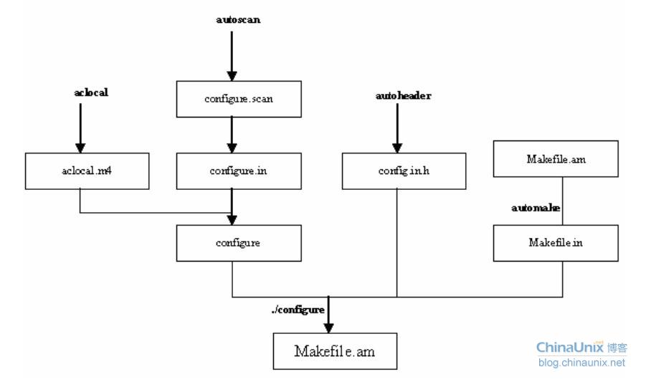

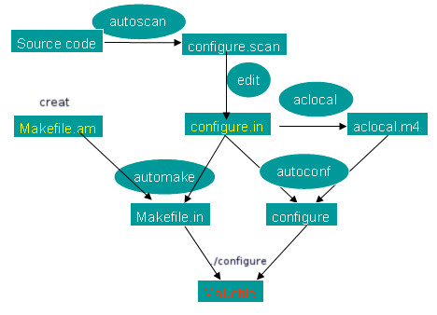

## FAQ

1. If `AC_PROG_LIBTOOL' is in `configure.in', make sure Makefile.am:3: its definition is in aclocal's search path.

原因：

解决方案：在当前目录下执行 libtoolize